KICKAPOO NATION SCHOOL
P.O. Box 106
400 1st St.
Powhattan, KS 66527
(785) 474-3364
Fax (785) 474-3530

2/28/2023

To: Vendors E-Rate
From: Michael Couch, KNS Superintendent
RE: Kickapoo Nation Schools E-Rate Request for Proposal
Date: 2/28/2023

Kickapoo Nation Schools is seeking listed equipment. This equipment must be:

* installed and configured into existing racks,
* patch cables will need to be replaced as needed and organized
* old equipment must be removed from racks,
* access points will need to be installed and configured

A mandatory walk through by the vendor is required here on the campus of Kickapoo Nation School prior to placing your bid, 400 1st Street, Powhatan, Kansas.

Bids should be submitted to achi@ketia.org and mcouch@ketia.org
Deadline: 3/14/2023

Thank you,
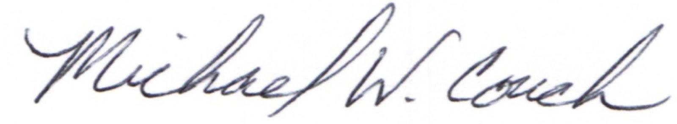
Michael Couch

“Home of the Warriors”

(PL-100-297 Grant School)

